**Name:- Dharan Gowda Superset id:-6387532**

**Create a react app for Student Management Portal named StudentApp and create a component named Home which will display the Message “Welcome to the Home page of Student Management Portal”. Create another component named About and display the Message “Welcome to the About page of the Student Management Portal”. Create a third component named Contact and display the Message “Welcome to the Contact page of the Student Management Portal”. Call all the three components**

**1. Create a new React project**

Open Visual Studio Code terminal and run:

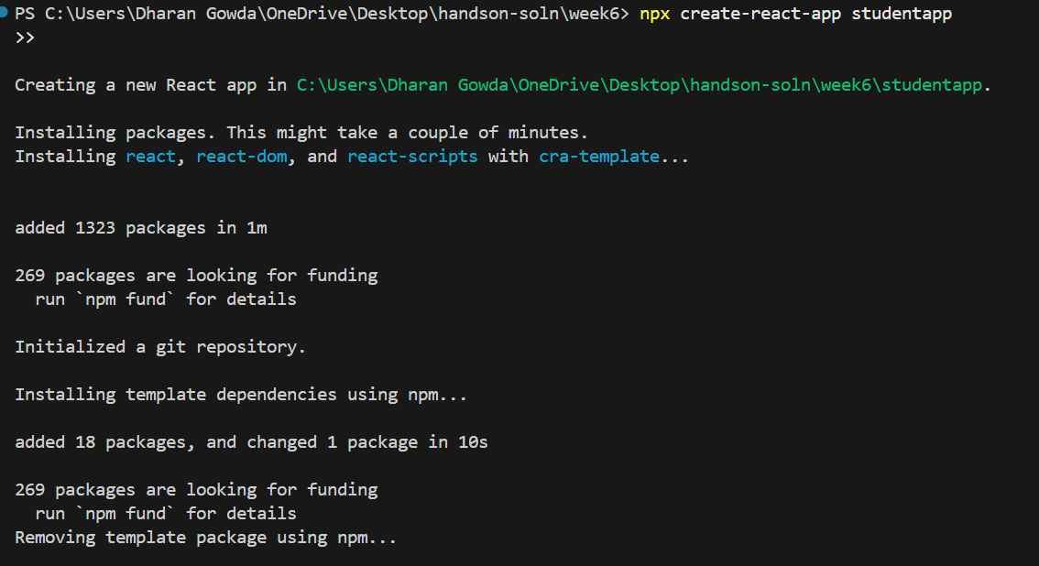

**2. Navigate into the project folder**

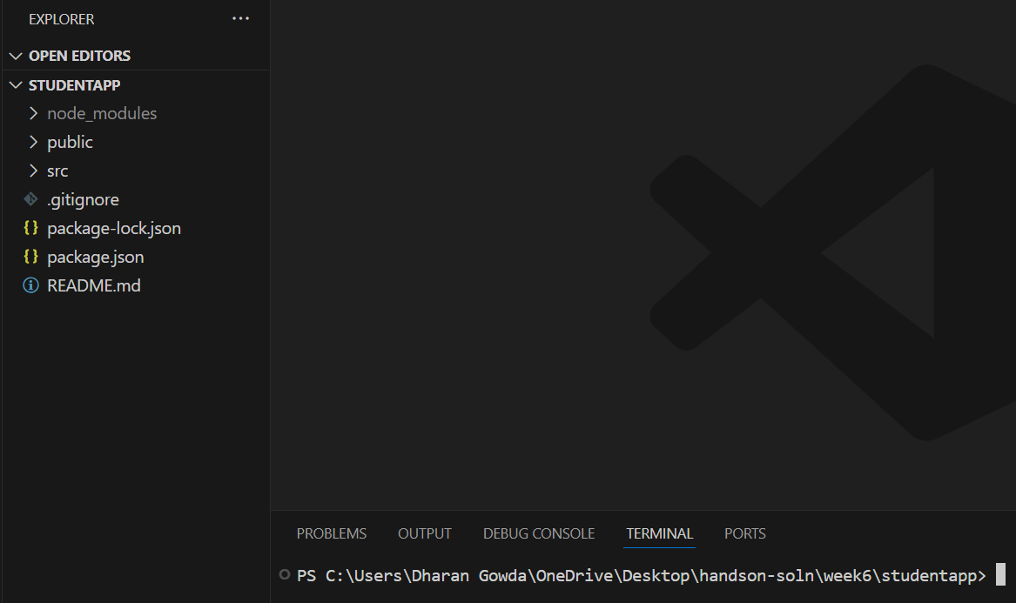

3. **Create a folder named Components inside src**

4. **Create Home.js inside Components**

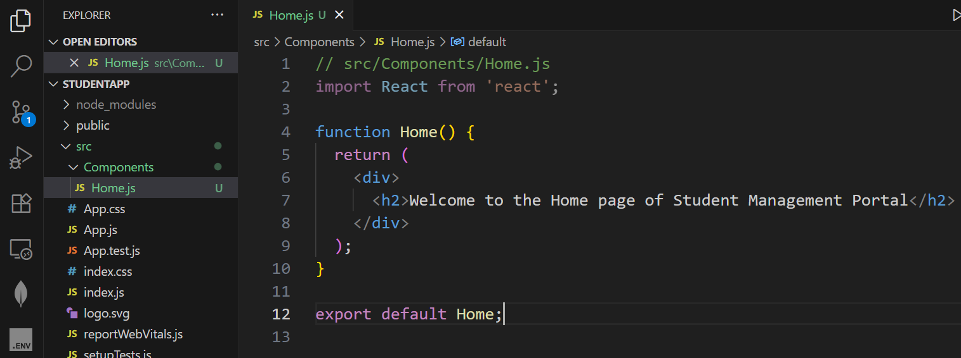

5. **Create About.js inside Components**

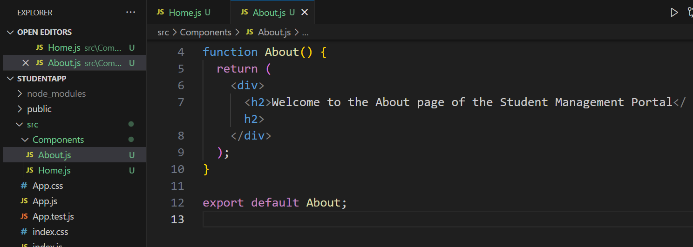

6. **Create Contact.js inside Components**

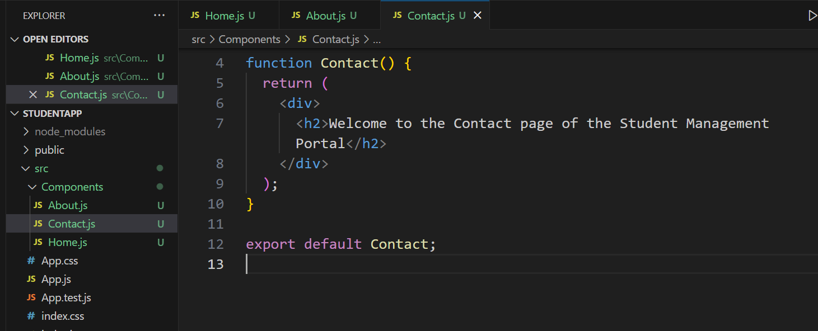

7. **Edit App.js to use all three components**

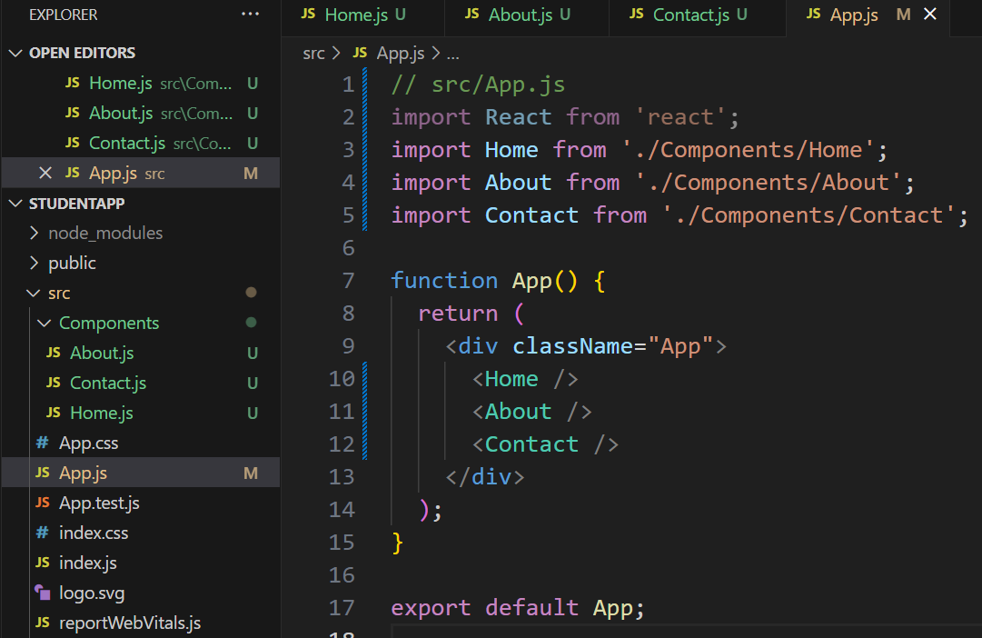

8. **Run the React app**

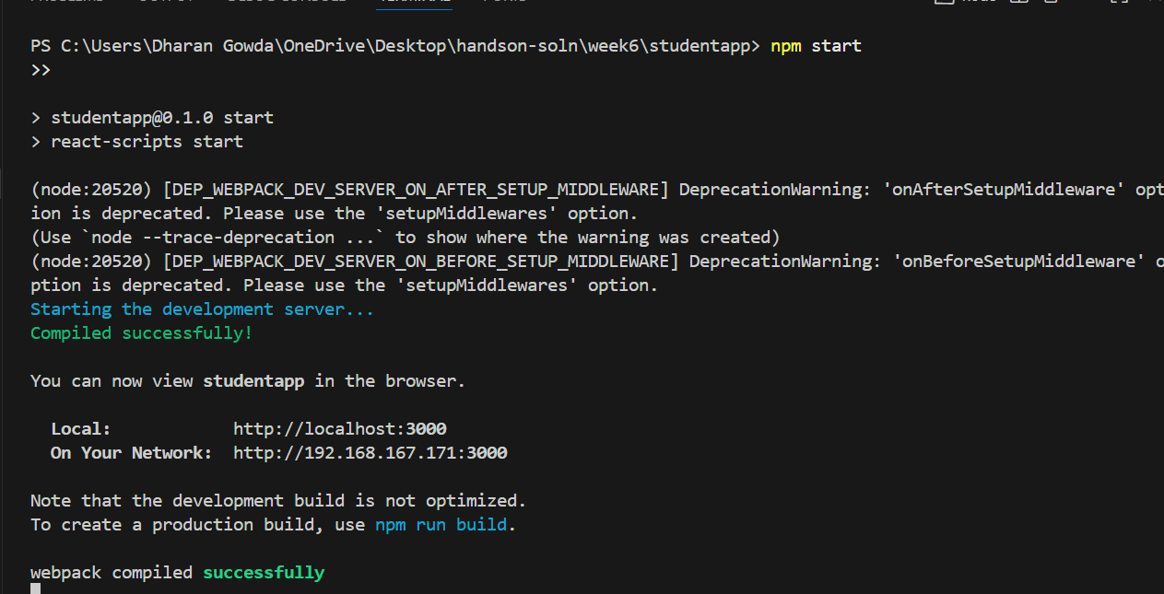

9. **Open the app in browser**

